***ASSIGNMENT 2***

***NAME:*** *KOLLI LOKESH*

***REG:*** *20BCI0215*

***E-MAIL:*** [***kolli.lokesh2020a@vitstudent.ac.in***](mailto:kolli.lokesh2020a@vitstudent.ac.in)

***VIT VELLORE***

**create, update, delete commands in mysql**

**create tables and perform joins in mysql**

**create, update, delete commands in mongo**

**-- Create the employee table**

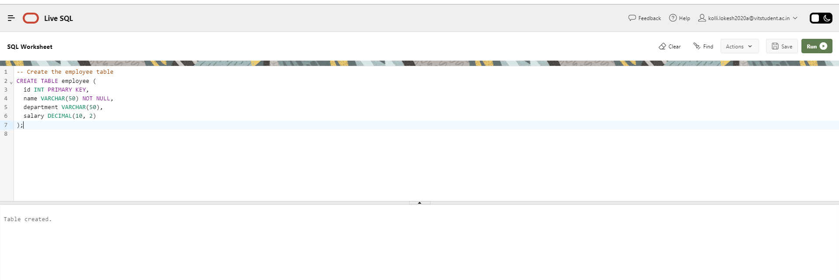

**-- Insert sample data into the employee table**

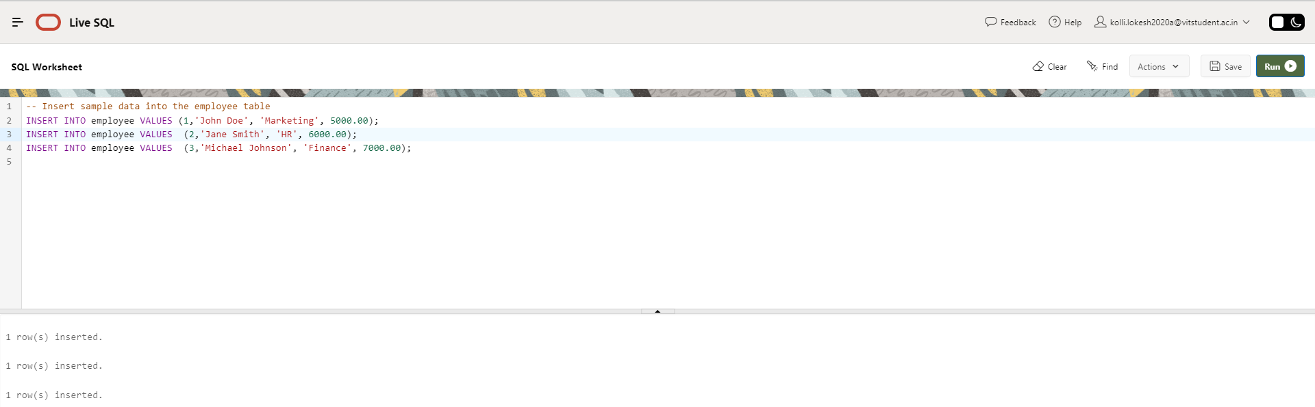

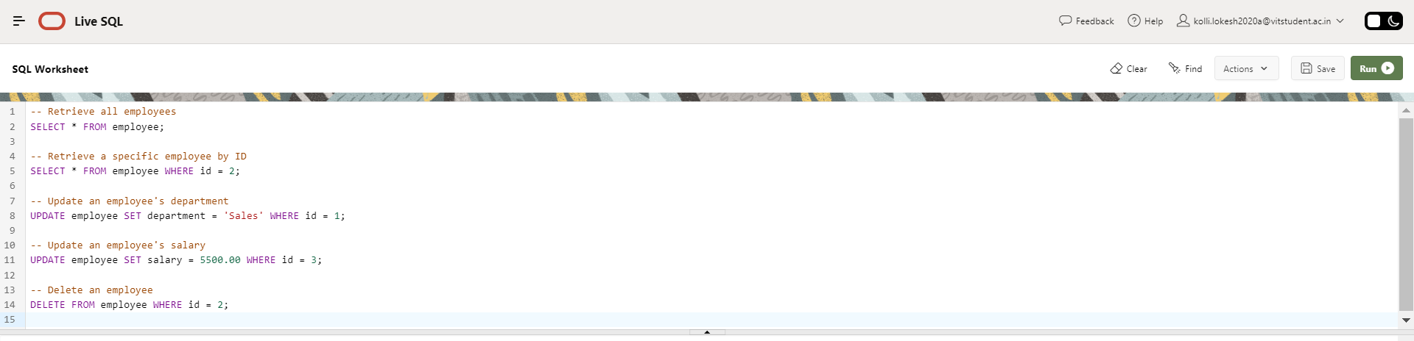

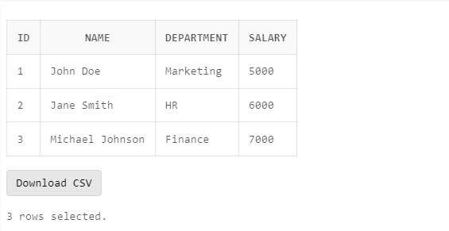

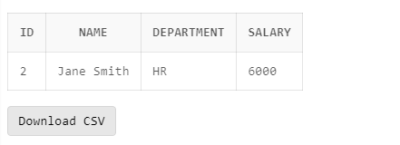

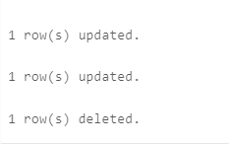

**create tables and perform joins in mysql**

**-- Create the departments table**

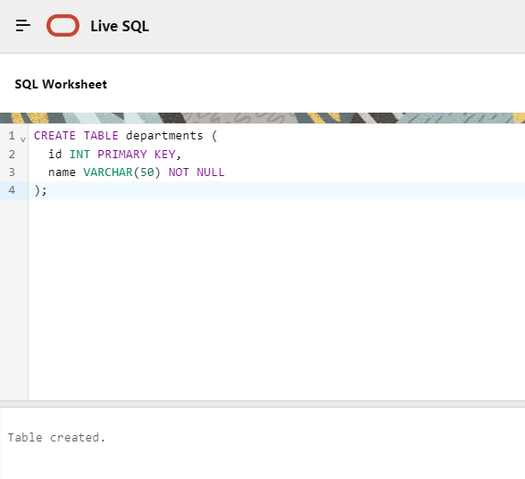

**-- Insert sample data into the departments table**

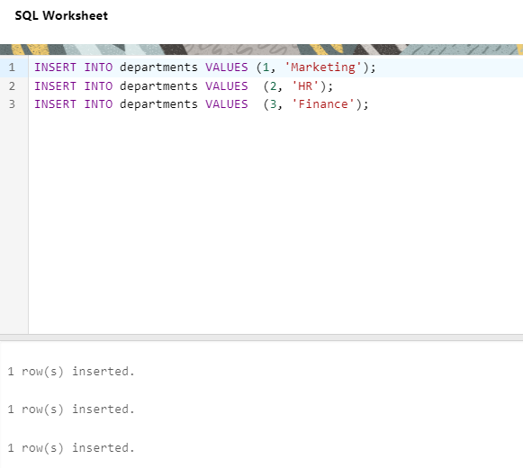

**-- Create the employees table**

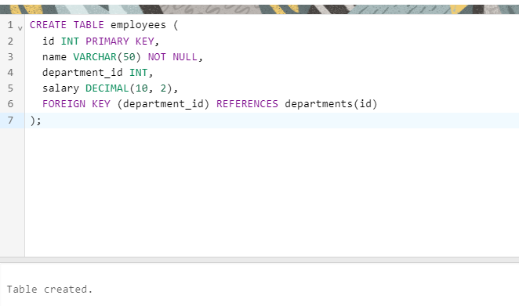

**-- Insert sample data into the employees table**

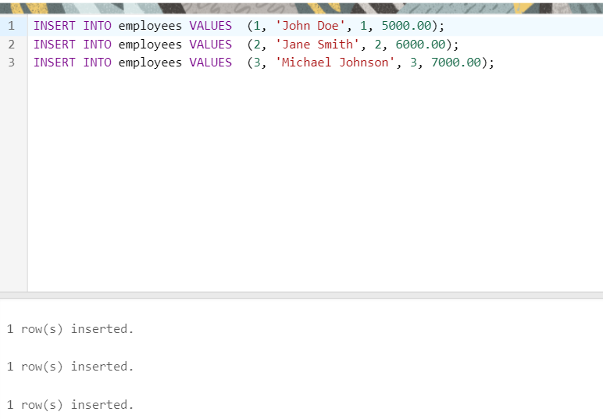

**-- Perform inner join between employees and departments**

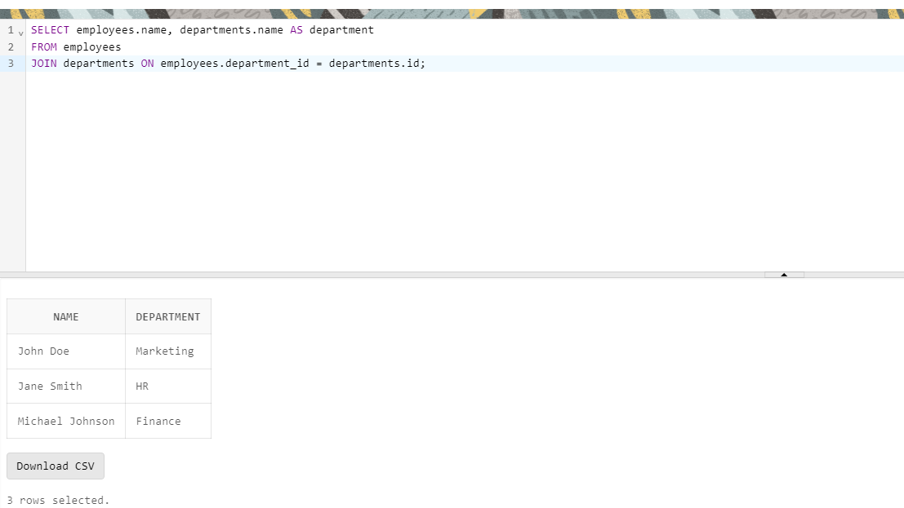

**-- Perform left join between employees and departments**

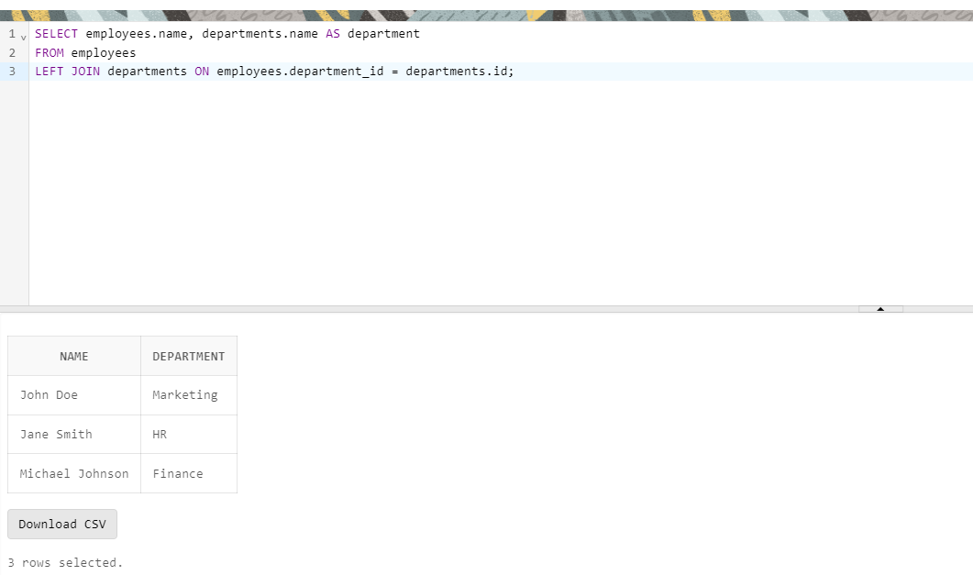

**-- Perform right join between employees and departments**

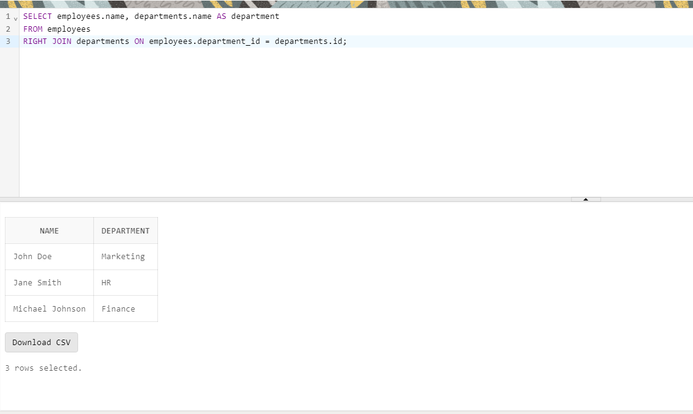

**-- Perform full outer join between employees and departments**

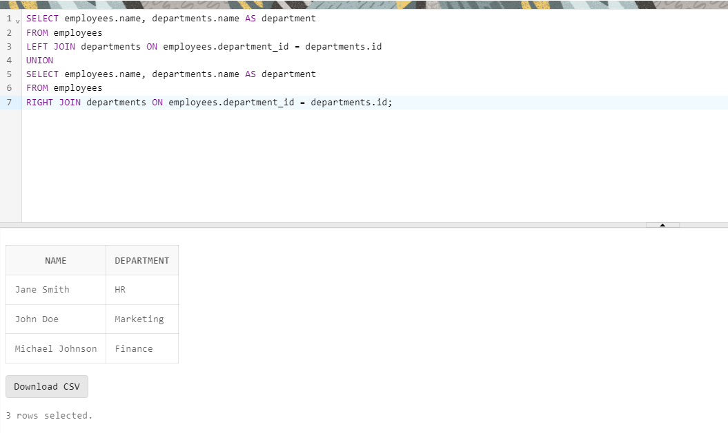

**create, update, delete commands in mongo**

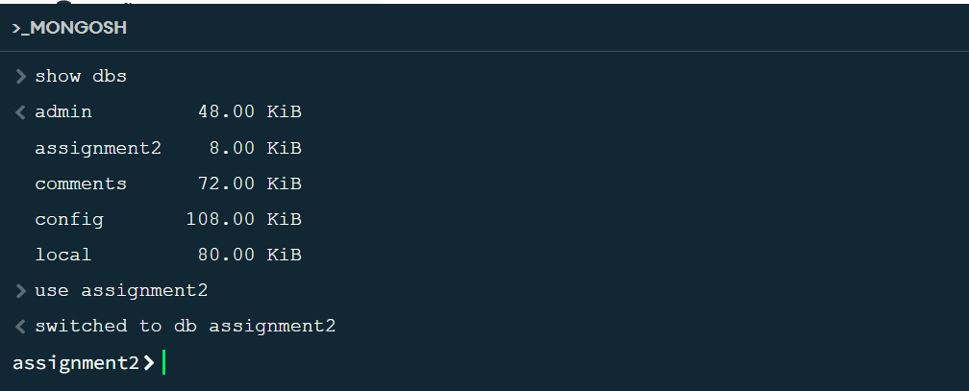

**Create collection:**

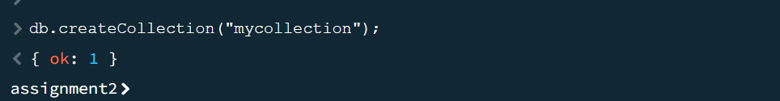

**Insert in to the collection:**

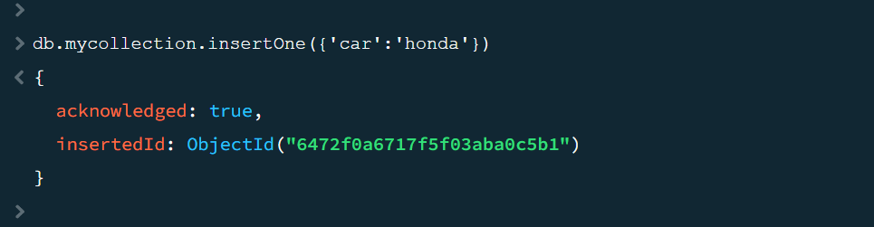

**Update the collection:**

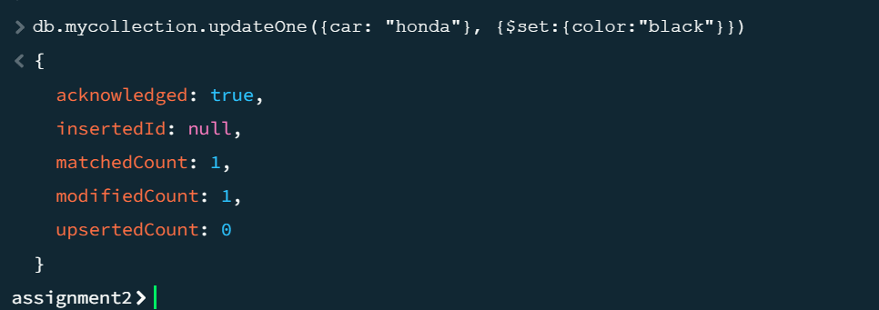

**Delete from the collection:**

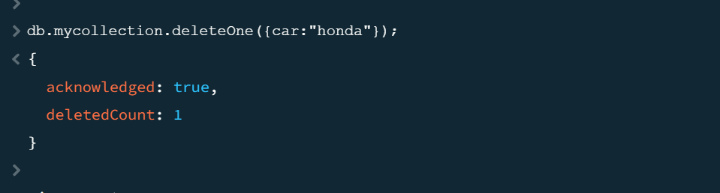

**Count of documents in the collection:**

